|  | 2814ICT/7003ICT – Data Management / Database Design  School of Information & Communication Technology |
| --- | --- |

**Lab 4.4 Exercise**

**1. Write the MySQL statements.**

For the given MovieCo ERD below, write MySQL statements:

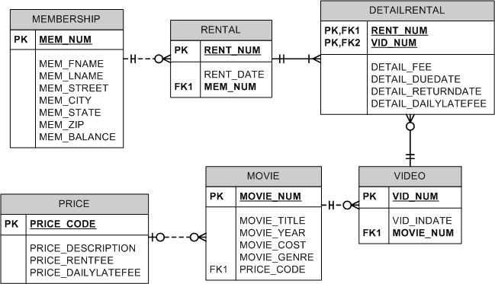

a) Find the movies which cost more than average movie cost. Show movie title, year and cost. Append the dollar sign ($) at the beginning of movie cost.

***Hints:***

* Use a subquery to obtain the average movie cost from MOVIE table.
* In the outer query, use CONCAT function to add $ sign.

**Your answer:**

Select MOVIE_TITLE ,MOVIE_YEAR ,CONCAT(‘$’,MOVIE_COST)AS MOVIE_COST from MOVIE WHERE MOVIE_COST > (Select AVG(MOVIE_COST ) from MOVIE )

b) Find the movies that have the same genre and price code as the movie Time to Burn.

***Hints:***

* Use a subquery to obtain the genre and price code for movie Time to Burn.
* In the outer query, match (MOVIE_GENRE, PRICE_CODE) with the output from the subquery.

**Your answer:**

SELECT * FROM MOVIE WHERE MOVIE_GENRE = (SELECT MOVIE_GENRE FROM MOVIE WHERE MOVIE_TITLE =’Time to Burn’ ) AND PRICE_CODE =(SELECT PRICE_CODE WHERE MOVIE_TITLE =’Time to Burn’)